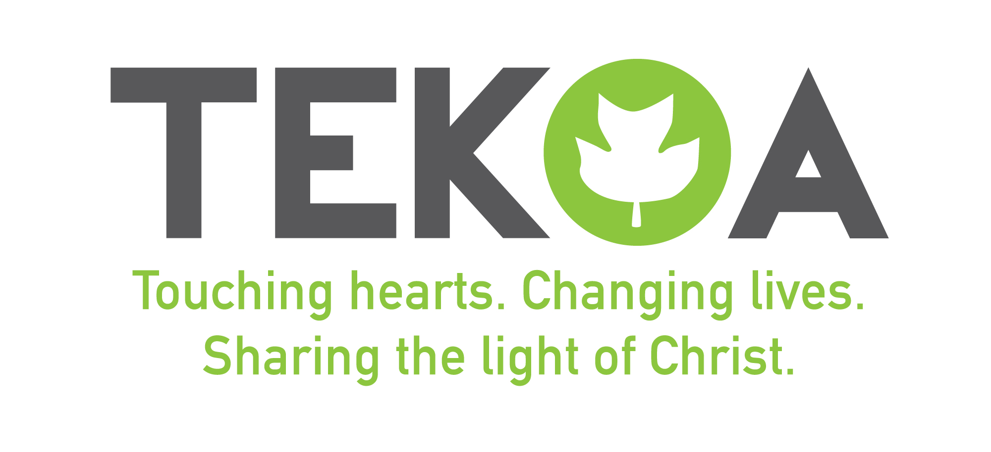
Retreats and Hospitality Director Job Description

General Description of Position
The Retreats and Hospitality Director serves as a vital piece of the Tekoa ministry. Their primary function is to support the work of Camp Tekoa with a focus on creating space for the spiritual development of all retreat guests while offering excellence in the guest experience and extending the mission of Tekoa into the world. The Retreats and Hospitality Director works in relationship with the Executive Director, Camp Tekoa Board of Trustees, staff, campers, parents, alumni, retreat leaders, and participants to fulfill the mission and achieve objectives. The Retreats and Hospitality Director reports to the Executive Director.

Specific Responsibilities
- Oversee the management of the Retreat program planning
  - Camp Tekoa is a year-round ministry full of many types of retreats and guest groups; the Retreats and Hospitality Director is responsible for coordinating them all
  - Working with program staff, ensure the program is properly ready for guest groups
  - Working with the Maintenance staff, ensure the site is clean and prepared and all needs are anticipated and met
    - Cleanliness: Tekoa prides itself on having a site that is properly cleaned, prepared and ready for groups. It is of the utmost importance that the RHD inspects and ensures the site is ready to welcome guests regularly

- Develop human resources to provide excellent retreat experiences
  - The management of weekend and mid-week retreats requires many human resources
  - Schedule Program Interns for weekend hosting and support
  - Schedule weekend staff to manage the work of running elements, lifeguarding, store management and supporting the kitchen
  - Cultivate strategic partnerships in the community to better elevate the number of staff available for retreat work

- Host and facilitate ministry retreats
  - The RHD is the primary person responsible for management of hosting responsibilities
  - Build a calendar for hosting that involves the Program Interns, Program Director and Executive Director
  - Train all year-round staff and seasonal staff how to properly orient and host groups
  - Provide all hosted user groups and retreat groups with a welcome orientation
  - Be on call to assist groups and guests at all times when hosting
  - Be on call for hosts when not scheduled to answer their questions and provide support

- Develop Tekoa-led ministry retreats
  - Create weekends of worship the develop the spiritual life of weekend guests
  - Build retreats that attract campers to register directly (in addition to those we host)
  - Fill calendar dates that are vacant by ensuring quality programming throughout the year
  - Working with Christian denominations, host denominational retreats
  - Explore growing retreats like Confirmation, Camp Jim (special needs program), Winter Retreats and summer camper retreats

- Support the development of Alumni retreats
  - Working with the Alumni Coordinator, develop retreats that encourage former staff to come back and experience Tekoa as an adult
  - Coordinate an annual celebration with the Alumni Coordinator to honor the legacy ministry of Camp Tekoa

- Assist with the work of Marketing for Camp Tekoa
  - Working with the Executive Director, develop a plan for Tekoa Marketing
  - Guide the work of Interns and marketing firms in social media
  - Work with marketing for Retreats, Summer Camp and Afterschool

- Support the work of summer camp
  - In the summer season, the RHD will work alongside the Program Director to offer support to staff, campers and parents, while continually working on retreat planning
  - Assist with training and development of summer staff
  - Work alongside the Program Director to provide quality summer camp experiences
  - If a guest group is booked at the end of camp, the RHD will manage that group and the responsibilities

- Prepare and maintain an annual retreat budget for specified areas
  - Prior to the annual November Board Meeting, plan a retreat budget for the next fiscal year
  - Throughout the year, track and manage spending in all areas of the retreat budget
  - Consult with the Business Manager regarding any major changes to the annual program budget
  - Intentionally assess and build future projections for all facilities and equipment needs and repairs related to the program

- Support the ministry of Tekoa Afterschool
  - Offer administrative support as needed
  - Offer program support as needed
    - Cover Afterschool and Break Camps in the absence of the Afterschool Director and Program Director
    - Engage with campers during their time on the site
    - Be a substitute bus driver if needed
    - Support the fall Afterschool fundraiser event

- Responsible for the health and well-being of self, staff and campers
  - Practice and enforce all camp safety regulations and emergency procedures
  - When working with family groups, help treat camper injuries/illnesses within trained level of care

- Comply with (through written, verbal, and practice-based evidence) all retreat related sections of the American Camp Association standards for accreditation
  - Working with the Executive Director and seasonal staff, prepare all needed documentation and physical needs for ACA visits
  - Observe all ACA regulations and revise practices as needed

- Serve as Onsite Director in absence of Executive Director and Program Director
  - The Executive Director has many offsite responsibilities including fund development and ministry beyond the site. As needed, the Retreats and Hospitality Director will step in and oversee any operations at Camp Tekoa including supervision of staff, emergency response and personnel concerns

- Personal Conduct
  - Act in a Christ-like manner in all professional and personal interactions
  - Abide by all camp policies including the Year-round Staff Manual and Summer Staff Manual
  - Be an active and visible presence in the camp, setting an example of commitment, excellence and caring
  - Be a team player, embodying the DNA and mission of Tekoa and looking for ways to support your fellow staff

- Perform all other duties and roles assigned by the Executive Director
  - The Retreats and Hospitality Director will be asked to cover many responsibilities that may be needed but not yet foreseen. Because this role is an administrative role, things come up. Be flexible!

